Software Design Description (SDD)
Based on IEEE 1016 – Adapted for Student Projects
Project Title: [University Lost and Found System]
Date: [13-12-2025]

Team Information
Name | Student ID | Role
Wesam Jaber Mohammed Almalki | 2240005660 | Team Leader
Faris Mohammed Saeed Alshahrani | 2240005572 | Project Manager
Ahmed Mohammed Ibrahim Albouainain | 2240006128 | Lead Developer
Fawaz Mohammed Saeed Alshahrani | 2240005571 | System Analyst
Jaber Saleh Mohammed Alsaikhan | 2240006539 | Tester / QA Engineer
Mohammed Talal Hussain Altuwairqi | 2240005295 | Presentation &  Documentation Designer
Fahad Nawar Mohammed  Alotaibi | 2240002024 | System Designer

Table of Contents

Team Information 1
Table of Contents 2
1. Introduction 4
1.2 Purpose 4
1.2 Scope 4
1.3 Intended Audience 4
1.4 References 4
2. System overview 4
2.1 Design Strategy 4
2.2 Architectural Style 4
3. Design Considerations 5
3.1 Assumptions 5
3.2 Constraints 5
3.3 Design Goals 5
3.4 Trade-offs 5
4. Architectural Design 5
4.1 Architectural Overview 5
4.2 Presentation Layer 5
4.3 Application Layer 5
4.4 Data Layer 6
4.5 Component Interaction 6
5. Detailed Design 6
5.1 Module description 7
5.2 Interactions Between Modules 8
6. Data Design 9
6.1 Database Overview 9
6.2 Table Descriptions 9
6.2.1 Table: users 9
6.2.2 Table: categories 9
6.2.3 Table: items 10
6.2.4 Table: claims 11
6.2.5 Table: messages 12
6.2.6 Table: notifications 12
7. External Interface 13
7.1 User Interface 13
7.2 Software Interfaces 13
7.3 Communication Interfaces 13
7.4 Hardware Interfaces 13
7.5 File and Image Upload Interface 13
8. Appendices 13
8.1 Glossary of Terms 13
8.2 Supporting diagrams 15
8.2.1 Entity–Relationship Diagram (ERD) 15
8.2.2 Architecture diagram 16
8.2.3 UML Diagrams: 17

1. Introduction

1.2 Purpose
The purpose of this Software Design Description (SDD) is to provide a detailed design overview of the Lost & Found System. This document describes the system architecture, software components, data structures, and interactions required to support the development and evaluation of the system.

1.2 Scope
The scope of the Lost & Found System includes designing the software structure that allows users to report lost and found items, manage item records, and facilitate communication between users. The system supports different user roles such as administrators and users. Implementation details outside the design level, such as deployment and maintenance, are not covered in this document.

1.3 Intended Audience
This document is intended for software developers, the course instructor. It provides sufficient design details to support system implementation, testing, and assessment.

1.4 References
[1] IEEE Computer Society.
IEEE Std 1016-1998: IEEE Recommended Practice for Software Design Descriptions.
IEEE, 1998.

[2] Oracle Corporation.
MySQL Workbench – Database Design and Modeling Tool.
Oracle Corporation.
Used for designing Entity-Relationship Diagrams (ERD) and creating database schemas for the system.
[3] Mermaid.js Contributors.
Mermaid.js – Diagramming and Charting Tool.
Mermaid.js Project.
A JavaScript library used to generate UML diagrams such as Sequence Diagrams, Class Diagrams, and Flowcharts to support the Architectural Design and Detailed Design sections of this document.
[4] Project Team.
Software Requirements Specification (SRS) – University Lost and Found System.
CSC 305: Software Engineering, Term 1, Academic Year 2025/2026.

2. System overview
The University Lost and Found Management System is an interactive web-based platform developed using Python and the Flask framework. The system provides a seamless and direct mechanism that enables authorized individuals within the university community (students, staff, and faculty) to report lost or found items.
The system does not rely on a dedicated administrative role for reviewing claims. Instead, it utilizes the following mechanisms:
- Self-Registration: Users create and manage their own accounts independently.
- Automated Claim Verification: Claims are initiated by providing a secret detail unique to the item. The system automatically verifies claims and, upon successful verification, enables a secure internal messaging system to facilitate communication between the finder and the claimant.

2.1 Design Strategy
The system adopts a Multi-Tier Client-Server Architecture, which separates the application into three distinct tiers to improve maintainability, scalability, and security.

Adopted Technologies | Primary Responsibility |  | Tier
Web Browser (Client-Side HTML/CSS/JS). | User Interface (UI) and input capture. |  | Presentation tier
Python (using the Flask framework | Processing requests, enforcing rules (claim/verification), and session management |  | Business logic tier
MySQL(Relational Database Management System). |  | Persistent storage of all system records (users, items, claims, messages). | Data Tier

2.2 Architectural Style
Context Diagram
Interaction with the System | External Entity
Logs in/out, registers an account, reports items, searches, and submits claims | User
Provides persistent storage for structured data (Items, Claims, Users, Messages). | Database (MySQL)
Sends notifications to users regarding new claims or item status. | Notification System

3. Design Considerations

3.1 Assumptions
User Integrity: It is assumed that university members (students and staff) will use the platform with integrity and honesty to promote community engagement, reducing the need for aggressive automated fraud detection.
Authentication Availability: The system assumes the availability of a secure university login API or a mock mechanism to handle user verification during the development and testing phases.
Hardware Availability: Users are assumed to have access to standard hardware interfaces, including internet-enabled devices (desktop or mobile).

3.2 Constraints
Technology Stack: The backend must be developed using Python with the Flask framework.
Database: The system must utilize a relational database, specifically SQLite or MySQL.
Communication Boundaries: Direct messaging is strictly limited to the internal scope of lost/found item communication and must not function as a general social messaging platform.
Schedule: All development and final code must be completed within the academic term

3.3 Design Goals
Privacy and Safety: A primary design goal is to protect user identity and property. This is achieved by implementing the "Secret Detail" verification mechanism, ensuring ownership is confirmed before contact details are shared.
Usability and Portability: The system must be responsive and accessible across various devices (mobile, tablet, desktop) and operating systems (Windows, Linux, macOS) via standard web browsers.
Performance: The architecture is designed to support up to 200 concurrent users with a response time of less than three seconds for fundamental transactions.
Maintainability: By enforcing a layered architecture and utilizing a standard framework (Flask), the system aims to be easily maintainable, allowing for future extensions such as third-party integrations which are currently out of scope.

3.4 Trade-offs
Internal Chat vs. External chat:
Decision: The system implements a private, internal chat room rather than chatting with external platforms (e.g., WhatsApp, Telegram).
Trade-off: While external chatting might offer more convenience, building an internal secure chat ensures the system maintains control over data privacy and keeps the context strictly on lost/found items.

Web-Based vs. Mobile App:
Decision: The system is designed as a responsive web application.
Trade-off: This sacrifices the potential performance optimization and push notification capabilities of a native app in exchange for broader portability and lower development time, ensuring the system works on all devices immediately.

4. Architectural Design
The Lost and Found System is a web-based client–server application designed using a layered architectural approach. This design separates the system into distinct layers to improve maintainability, scalability, and security.
The architecture supports core system functions including user authentication, reporting lost and found items, searching and filtering items, ownership verification, and secure user communication.

4.1 Architectural Overview
The system follows a three-layer architecture:
Application Layer
Presentation Layer
Data Layer
Each layer has clearly defined responsibilities and communicates with adjacent layers through well-defined interfaces.

4.2 Presentation Layer
The Presentation Layer provides the user interface of the system and is accessed through standard web browsers on desktop and mobile devices.
Responsibilities:
- Display login and registration pages
- Provide forms for reporting lost and found items
- Display item listings with search and filter options
- Allow users to submit item claims and view claim status
- Enable in-system messaging between users

4.3 Application Layer
The Application Layer contains the core business logic and is implemented using a Flask-based backend.
Responsibilities:
- Process HTTP requests from the Presentation Layer
- Validate user input and enforce business rules
- Manage authentication and authorization
- Coordinate interactions between system modules
Main Components:
- Authentication Module
- User Management Module
- Item Reporting and Management Module
- Claim Verification Module
- Messaging Module
- Notification Module

4.4 Data Layer
The Data Layer is responsible for persistent data storage.
Responsibilities:
- Store user account information securely
- Maintain lost and found item records
- Store claim and verification data
- Persist chat messages and notification data

4.5 Component Interaction
User requests are initiated through the Presentation Layer and sent to the Application Layer via HTTP. The Application Layer processes the requests, applies the required business logic, and interacts with the Data Layer for data storage and retrieval. The processed results are then returned to the Presentation Layer for display.

5. Detailed Design
This section provides a detailed description of the main modules of the Lost & Found System, including their responsibilities, inputs, outputs, and interactions.

5.1 Module description
Module Name | Responsibility | Inputs | Outputs | Notes / Design References
Authentication Module | Handles user registration, login, logout, and session management to ensure secure system access. | Username, Password | Authentication result (success/failure), Active user session | Implements password hashing and secure session handling as defined in the Security Requirements.
User Management Module | Manages user accounts, including retrieving and updating user profile information. | User ID, Profile data | User profile information, Updated user data | Interacts directly with the users database table.
Lost Item Reporting Module | Allows authenticated users to submit detailed reports for lost items. | Item name, Description, Category, Location, Secret Detail, Image (optional) | Lost item record stored in the database | Item status is initialized as active upon submission.
Found Item Reporting Module | Allows authenticated users to submit reports for found items. | Item name, Description, Category, Location, Secret Detail, Image (optional) | Found item record stored in the database | Follows the same workflow as the Lost Item Reporting Module.
Item Management Module | Manages the lifecycle of lost and found items, including updates, retrieval, and status changes. | Item ID, Status updates | Updated item details, Updated item status | Supported statuses include active, claimed, returned.
Search & Filtering Module | Enables users to search and filter lost and found items based on multiple criteria. | Search keywords, Category, Item type | List of matching items | Optimized using indexed database fields for efficient queries.
Claim & Verification Module | Handles ownership claims and verifies item ownership using the Secret Detail mechanism. | Item ID, Secret Detail provided | Claim status (Pending / Approved / Rejected) | Core verification logic of the system; interacts with the claims table.
Internal Chat Module | Provides secure internal communication between the finder and the verified owner. | Claim ID, Message text | Sent and received messages | Communication is enabled only after claim approval.
Notification Module | Generates and delivers system notifications related to important events. | User ID, Event type | Notification message | Notifications are stored in the notifications table; external notifications are out of scope.
Database Access Module | Manages all database interactions in a secure and controlled manner. | SQL queries, Data requests | Retrieved or stored data | Acts as an abstraction layer between application logic and the database.

5.2 Interactions Between Modules
Module | Interacts With | Interaction Purpose
Authentication Module | User Management, Database Access | Create accounts, validate login credentials, manage sessions
User Management Module | Database Access | Retrieve/update user profile data
Lost Item Reporting Module | Item Management, Database Access, Notification | Create lost item record; notify users if needed
Found Item Reporting Module | Item Management, Database Access, Notification | Create found item record; notify users if needed
Item Management Module | Database Access, Search & Filtering, Claim & Verification | Store/retrieve items; update item status; provide item details
Search & Filtering Module | Item Management, Database Access | Query items by keywords/category/type/status
Claim & Verification Module | Item Management, Database Access, Notification, Internal Chat | Create claim, verify Secret Detail, update claim/item status, enable chat
Internal Chat Module | Database Access, Notification | Store messages; notify receiver of new message
Notification Module | Database Access | Store and deliver in-system notifications
Database Access Module | All modules | Central secure interface for DB operations

6. Data Design

6.1 Database Overview
The database is designed to support the University Lost and Found System by managing users, lost and found item reports, ownership claims, internal communication, and system notifications.
It follows a relational database model and ensures data integrity through primary keys, foreign keys, and referential constraints.
The design supports secure authentication, item verification using a Secret Detail, and controlled communication between users.
The database consists of the following main tables:
- users
- categories
- items
- claims
- messages
- notifications

6.2 Table Descriptions

6.2.1 Table: users
Attribute Name | Data Type | Constraints | Description
user_id | INT | PK, Auto Increment, NOT NULL | Unique identifier for each user
username | VARCHAR(50) | UNIQUE, NOT NULL, Indexed | Username used for login
password_hash | VARCHAR (255) | NOT NULL | Hashed password for secure authentication

6.2.2 Table: categories
Attribute Name | Data Type | Constraints | Description
category_id | INT | PK, Auto Increment, NOT NULL | Unique identifier for each category
category_name | VARCHAR(50) | UNIQUE, NOT NULL | Name of the item category
category_description | VARCHAR(200) | NULL | Optional description of the category
icon_path | VARCHAR(100) | NULL | File path of the category icon
display_order | INT | DEFAULT 0 | Controls display order in the UI
is_active | TINYINT(1) | DEFAULT 1 | Indicates whether the category is active

6.2.3 Table: items
Attribute Name | Data Type | Constraints | Description
item_id | INT | PK, Auto Increment, NOT NULL | Unique identifier for each item
user_id | INT | FK → users(user_id), NOT NULL | User who reported the item
item_type | ENUM('lost','found') | NOT NULL | Type of report (lost or found)
item_name | VARCHAR(100) | NOT NULL | Name of the reported item
category | VARCHAR(50) | Indexed, NOT NULL | Category of the item
description | TEXT | NOT NULL | Detailed description of the item
secret_detail | VARCHAR(255) | NOT NULL | Hidden detail used for ownership verification
location | VARCHAR(200) | NOT NULL | Location where the item was lost or found
date_reported | TIMESTAMP | DEFAULT CURRENT_TIMESTAMP | Date and time the item was reported
status | ENUM('active','claimed','returned','cancelled') | DEFAULT 'active', Indexed | Current status of the item
image_path | VARCHAR(255) | NULL | Path to the uploaded item image

6.2.4 Table: claims
Attribute Name | Data Type | Constraints | Description
claim_id | INT | PK, Auto Increment, NOT NULL | Unique identifier for each claim
item_id | INT | FK → items(item_id), NOT NULL | Item being claimed
claimant_id | INT | FK → users(user_id), NOT NULL | User submitting the claim
secret_detail_provided | TEXT | NOT NULL | Ownership proof provided by claimant
claim_status | ENUM('pending','approved','rejected') | DEFAULT 'pending', Indexed | Current status of the claim
claim_date | TIMESTAMP | DEFAULT CURRENT_TIMESTAMP | Date and time the claim was submitted
reviewed_date | TIMESTAMP | NULL | Date when the claim was reviewed
notes | TEXT | NULL | Reviewer notes or comments

6.2.5 Table: messages
Attribute Name | Data Type | Constraints | Description
message_id | INT | PK, Auto Increment, NOT NULL | Unique identifier for each message
claim_id | INT | FK → claims(claim_id), NOT NULL | Claim related to the message
sender_id | INT | FK → users(user_id), NOT NULL | User who sent the message
receiver_id | INT | FK → users(user_id), NOT NULL | User who received the message
message_text | TEXT | NOT NULL | Message content
sent_date | TIMESTAMP | DEFAULT CURRENT_TIMESTAMP, Indexed | Date and time the message was sent
is_read | TINYINT(1) | DEFAULT 0 | Indicates whether the message has been read

6.2.6 Table: notifications
Attribute Name | Data Type | Constraints | Description
notification_id | INT | PK, Auto Increment, NOT NULL | Unique identifier for each notification
user_id | INT | FK → users(user_id), NOT NULL | User receiving the notification
notification_type | ENUM | NOT NULL | Type of notification event
title | VARCHAR(100) | NOT NULL | Notification title
message | TEXT | NOT NULL | Notification message content
related_item_id | INT | FK → items(item_id), NULL | Related item (if applicable)
related_claim_id | INT | FK → claims(claim_id), NULL | Related claim (if applicable)
is_read | TINYINT(1) | DEFAULT 0, Indexed | Indicates whether the notification was read
created_date | TIMESTAMP | DEFAULT CURRENT_TIMESTAMP | Date and time the notification was created

7. External Interfaces
7.1 User Interface
The system provides a web-based user interface that allows users to interact with the Lost and Found system through a standard web browser.
The interface is designed to be simple and user-friendly, enabling users to perform actions such as registering accounts, submitting lost or found items, uploading images, submitting claims, and exchanging messages after claim approval.
HTML and CSS are used to structure and style the web pages, while Jinja2 templating is used to dynamically display data retrieved from the backend.

7.2 Software Interfaces
The system interacts with several software components to operate correctly.
The backend of the system is developed using the Flask framework, which handles routing, request processing, and application logic.
The system uses SQLAlchemy as an Object-Relational Mapping (ORM) tool to communicate with the relational database.
The database stores information related to users, items, claims, messages, and uploaded images.
During development, The system design allows migration to other relational databases such as MySQL if required.

7.3 Communication Interfaces
Communication between the client and the server is handled using the HTTP protocol.
Users interact with the system by sending HTTP requests through their web browsers, and the server responds with appropriate HTML pages.
This request–response mechanism ensures reliable and efficient interaction between the user interface and backend services.

7.4 Hardware Interfaces
No specialized hardware interfaces are required for this system.
The application can be accessed using standard devices such as desktop computers, laptops, or mobile devices that have an internet connection and a web browser.

7.5 File and Image Upload Interface
The system supports uploading image files to provide visual evidence for lost or found items and during claim communication.
Uploaded images are stored on the server in a designated upload directory and are linked to the corresponding database records.
This functionality improves the claim verification process and enhances communication between users.

8. Appendices

8.1 Glossary of Terms
- User
Any person registered in the system with a unique username and password.
- Item
A record representing a lost or found object reported by a user.
- Lost Item
An item whose item_type = 'lost', created by a user who is searching for it.
- Found Item
An item whose item_type = 'found', created by a user who found it and wants to return it to the owner.
- Category
A logical grouping of items (e.g., Electronics, Documents, Accessories) used to help users filter and search.
- Claim
A request created by a user (claimant) to prove ownership of a lost item or to accept a found item.
- Claimant
A user who submits a claim for a specific item.
- Secret Detail
A piece of information known only to the real owner and stored with the item (e.g., serial number, a hidden mark).
- Secret Detail Provided
The information the claimant submits when creating a claim, used by the system/admin to validate ownership.
- Claim Status
The current state of a claim (e.g., pending, approved, rejected).
- Notification
A message generated by the system to inform a user of important events (e.g., new claim, claim decision, new message).
- Message
A direct text communication between two users, usually related to a claim.

8.2 Supporting diagrams

8.2.1 Entity–Relationship Diagram (ERD)
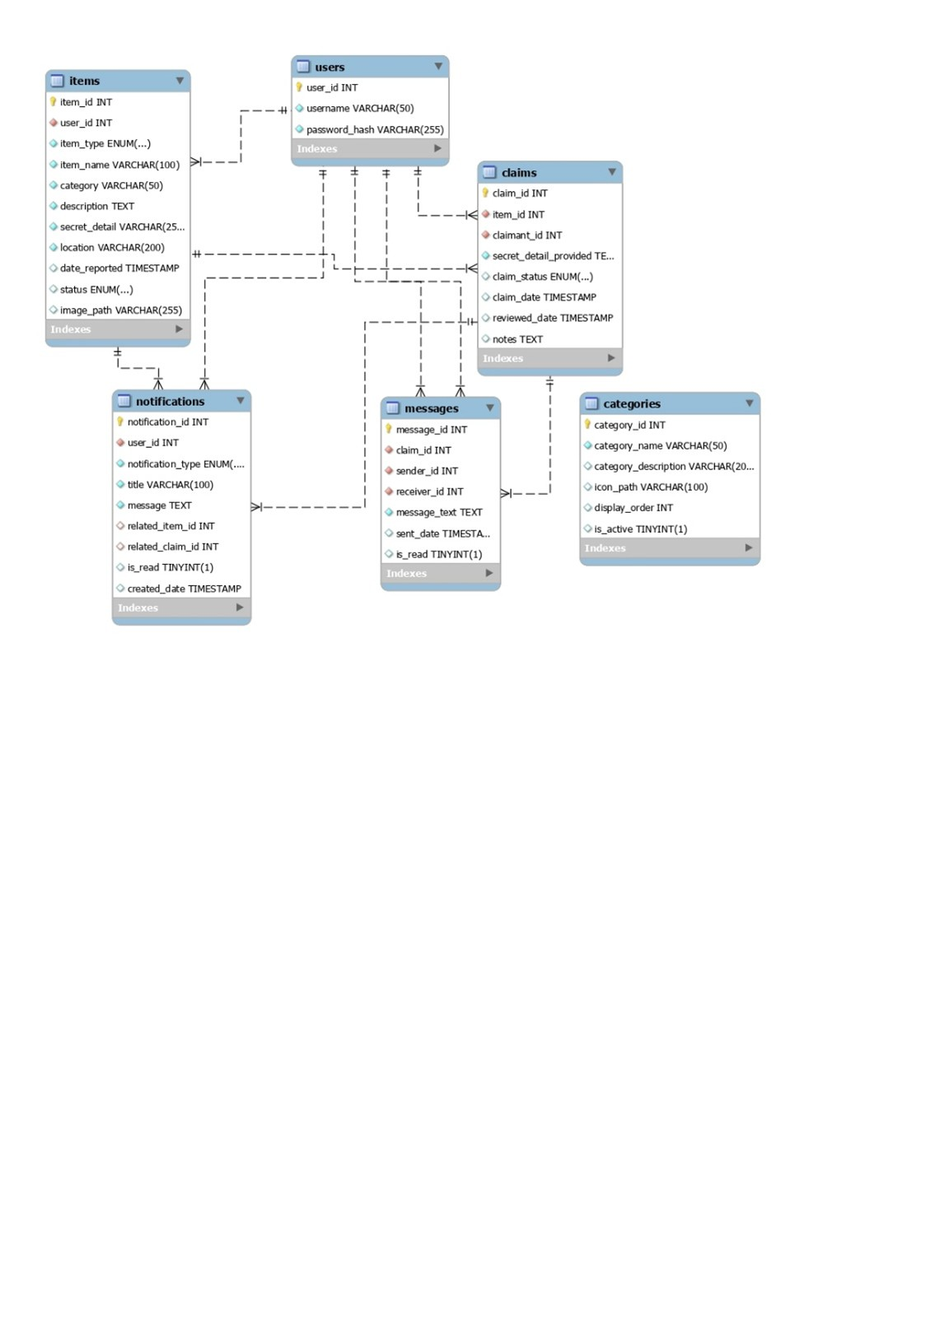

8.2.2 Architecture diagram
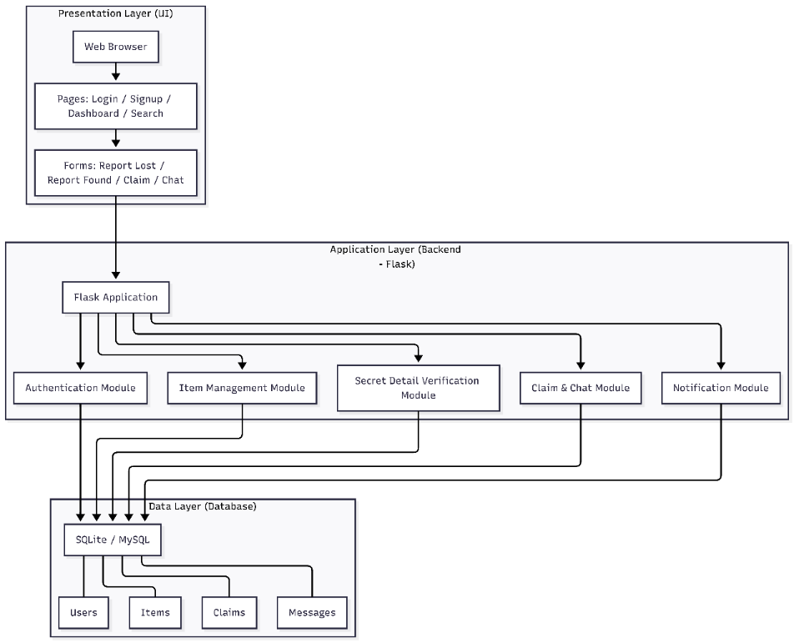

8.2.3 UML Diagrams:
sequence diagram for the User Login Process:
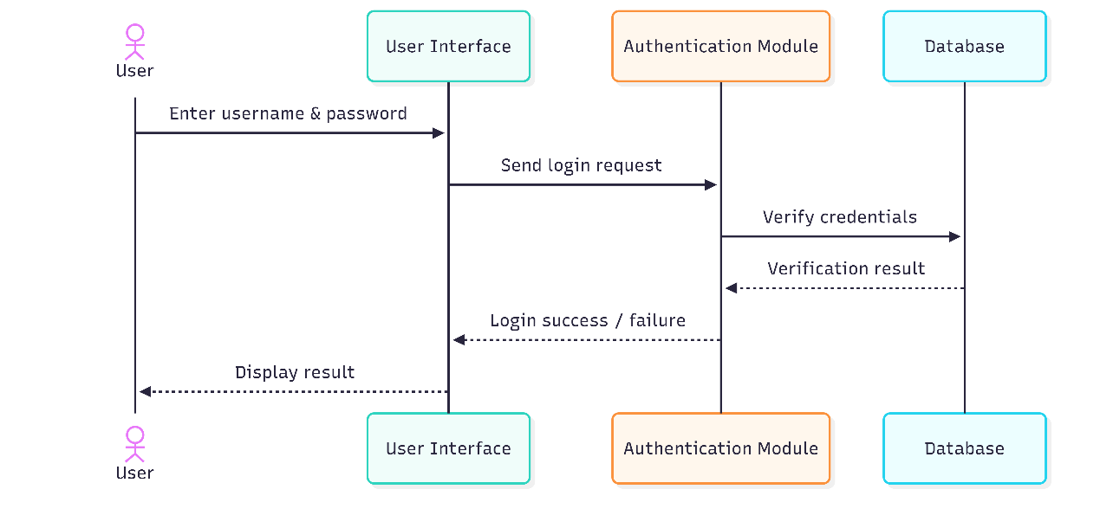
Class Diagram:
